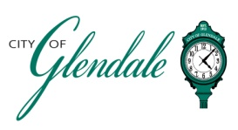
NOTICE OF PUBLIC MEETING
FRIDAY, DECEMBER 17, 2021 – 6:15 P.M.
BOARD OF ALDERMEN MEETING
TENTATIVE AGENDA

- MEETING CALLED TO ORDER

- ROLL CALL

- APPROVAL OF AGENDA

- APPROVAL OF THE NOVEMBER 15, 2021 MINUTES

- CITIZEN COMMENTS

- RESOLUTIONS

R40-21 A RESOLUTION AUTHORIZING THE EXECUTION OF A SUPPLEMENTAL COOPERATIVE AGREEMENT WITH ST. LOUIS COUNTY WHICH INCORPORATES CONSOLIDATED PLAN OF ST. LOUIS COUNTY AND SETS FORTH THE TERMS AND CONDITIONS FOR CONTINUED PARTICIPATION IN THE COMMUNITY DEVELOPMENT BLOCK GRANT PROGRAM AS ADMINISTERED THROUGH ST. LOUIS COUNTY

- ADJOURNMENT

This meeting will be held at the Algonquin Golf Club at 340 N. Berry Road and will be open to the public.

________________________
Benjamin DeClue
City Administrator/City Clerk Posted 5:00 P.M. December 16, 2021

